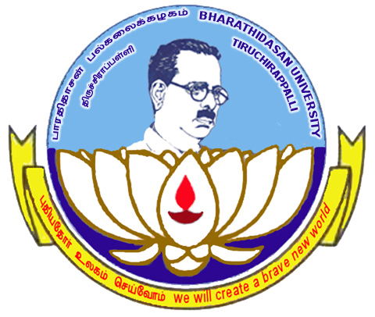

BHARATHIDASAN UNIVERSITY
TIRUCHIRAPPALLI –620 024
BDU FEST - 2025

(Inter – Collegiate Cultural Convergence)

TEAM REGISTRATION FORM

Name of the College :
Total No. of Participants :
Time and Date of Arrival :
Name of contact person with Mobile No:
(Note: Please write the participants names in capitals. Same names will appear in the certificates.)

Sl. No | Name of the Event | Name(s) of the Participants  with Dept. | Name(s) of Accompanists
MUSIC
01 | LIGHT VOCAL SOLO | 1. | 1.
01 | LIGHT VOCAL SOLO | 1. | 2.
02 | FOLK SONG SOLO | 1. | 1.
02 | FOLK SONG SOLO | 1. | 2.
03 | WESTERN  VOCAL SOLO | 1. | 1.
03 | WESTERN  VOCAL SOLO | 1. | 2.
04 | GROUP SONG INDIAN | 1 | 1
04 | GROUP SONG INDIAN | 2 | 2
04 | GROUP SONG INDIAN | 3 | 3
04 | GROUP SONG INDIAN | 4 | 3
04 | GROUP SONG INDIAN | 5 | 3
04 | GROUP SONG INDIAN | 6 | 3
05 | FOLK ORCHESTRA | 1. | 1.
05 | FOLK ORCHESTRA | 2. | 1.
05 | FOLK ORCHESTRA | 3. | 1.
05 | FOLK ORCHESTRA | 4. | 2.
05 | FOLK ORCHESTRA | 5. | 2.
05 | FOLK ORCHESTRA | 6. | 2.
05 | FOLK ORCHESTRA | 7. | 3.
05 | FOLK ORCHESTRA | 8. | 3.
05 | FOLK ORCHESTRA | 9. | 3.
THEATRE
06 | SKIT | 1. | 1.
06 | SKIT | 2. | 1.
06 | SKIT | 3. | 2.
06 | SKIT | 4. | 2.
06 | SKIT | 5. | 3.
06 | SKIT | 6. | 3.
 | SKIT TRAINER NAME
07 | MIME | 1. | 1.
07 | MIME | 2. | 1.
07 | MIME | 3. | 2.
07 | MIME | 4. | 2.
07 | MIME | 5.
07 | MIME | 6.
08 | REELS Creation  Based on BDU FEST | 1. | NIL
 | MIME TRAINER NAME
09 | MIMICRY | 1. | NIL
LITERARY
10 | ELOCUTION (English) | 1. | NIL
11 | ELOCUTION  (Tamil) | 1. | NIL

FINE ARTS
12 | CARTOONING | 1. | NIL
13 | RANGOLI | 1. | NIL
 | FINE ARTS TRAINER NAME
`
DANCE
14 | CLASSICAL DANCE SOLO | 1. | 1.
14 | CLASSICAL DANCE SOLO | 1. | 2.
14 | CLASSICAL DANCE SOLO | 1. | 3.
15 | FOLK DANCE (GROUP) | 1. KARAGAM GROUP/  2.OTHER TAMILNADU FOLK DANCE GROUP  (Select any one)
 |  | 1. | 1.
 |  | 2. | 1.
 |  | 3. | 2.
 |  | 4. | 2.
 |  | 5. | 3.
 |  | 6. | 3.
 |  | 7. | 4.
 |  | 8. | 4.
 |  | 9. | 5.
 |  | 10. | 5.
 | FOLK DANCE TRAINER NAME
16 | CULTURAL RALLY  fiyg;gz;ghl;L Nguzp | ALL PARTICIPANTS

CERTIFICATE
I hereby certify that the above participants for BDU FEST - 2025 are the bonafide students of this college. They will abide by the rules and regulations of the festival.

CULTURAL PROGRAMME OFFICER PRINCIPAL

Office seal with date:

Note : Eligibility: Bonafide students pursuing a full time course of study in University Departments / a college / an Institution (Day/Evening) affiliated to Bharathidasan University and below 25 years of age as on 31-12-2025 shall be eligible to participate in this festival.

- Strength of contingent: Maximum 40 Students + 6 Accompanists per college.

BHARATHIDASAN UNIVERSITY, TIRUCHIRAPPALLI –620 024
BDU FEST - 2025

(Inter – Collegiate Cultural Convergence)

PARTICIPANT’S PROFORMA

Recent Passport Size
Photo
(Attested by the Principal)

1) Name of the Participant :
2) Date of Birth :
3) Name of the College :
4) Degree and Year of Study :
4) Full Residential Address :

5) Contact Phone No. :
(Resi. & Mobile)

6) No. of times participated in the :
BDU FEST

7) Participating Events : 1.
2.
3.
4.
5.
6.
7.
8.
9.
10.

Signature of Participant Signature of Contingent In-charge

Signature of the PRINCIPAL
(with seal)
Note:

- The Photo of the Participant should be attested by the Principal. You are requested to make copies of this Proforma and each participant should submit a Separate Proforma.

